Math Department Syllabus
Tuscaloosa County High School

Teacher: Mrs. Fuller Room Number: 2506
Phone Number: 205-342-2670 E-Mail: sfuller@tcss.net

Course: Geometry and Advanced Geometry

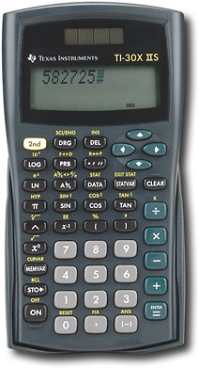
Materials Needed:
3-ring binder (1 ½ inch or larger)
Loose-leaf Paper
Pencils
Scientific Calculator TI-30XIIS (The only calculator allowed!!)
Colored Pencils
Highlighters
Remote Learners must have the ability to scan work and upload it
to Schoology. This can be done with a printer/scanner at home,
your notes app on an Iphone, or there are many other free
scanning apps.

Room Supplies (please send the following):
1 box of Kleenex or roll of paper towels
1 container of Clorox wipes or hand sanitizer

Guidelines for Success:
- NO CELL PHONES ALLOWED IN CLASS, THIS WILL RESULT IN A DISCPLINE REFERAL!
- Adhere to the Student Code of Conduct.
- Bring your materials to class each day.
- Adhere to all classroom rules and expectations.
- Be respectful of others and treat them as you would like to be treated.
- Cheating will result in an automatic zero. This includes, but is not limited to, plagiarism, copying assignments, giving answers, and talking during a test or quiz.
- No food or drink allowed in the classroom except for water

Grading:
Student grades will be computed using the point system. All assignments are given a total number of points possible.
- Class Assignments
- Homework: These assignments will be graded based on effort and participation. It is imperative that you attempt all homework assignments in this class. You learn math by doing math. It is that simple.

Missed Assignments/Late Work:
If you will be absent from class, you should log in the Schoology and check for notes and assignments for the day.

Conferences:
To request a conference, you may call the school at 342-2670 and leave a message. The
most efficient way to reach me is by email.

*If you do not know your information to gain access to INOW, please contact the front office to get that information. It is imperative that you keep up with your progress/performance in this class!

I have read, understand, and agree to abide by all rules and expectations as outlined in the course syllabus for Geometry or Advanced Geometry.

------------------------------------------------------------------------------------------------------------

Student Print Name:

________________________________________________________________________

Student Signature:

________________________________________________________________________

